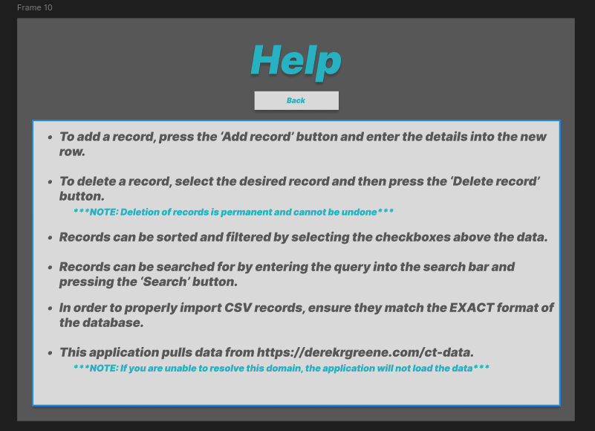
OLD
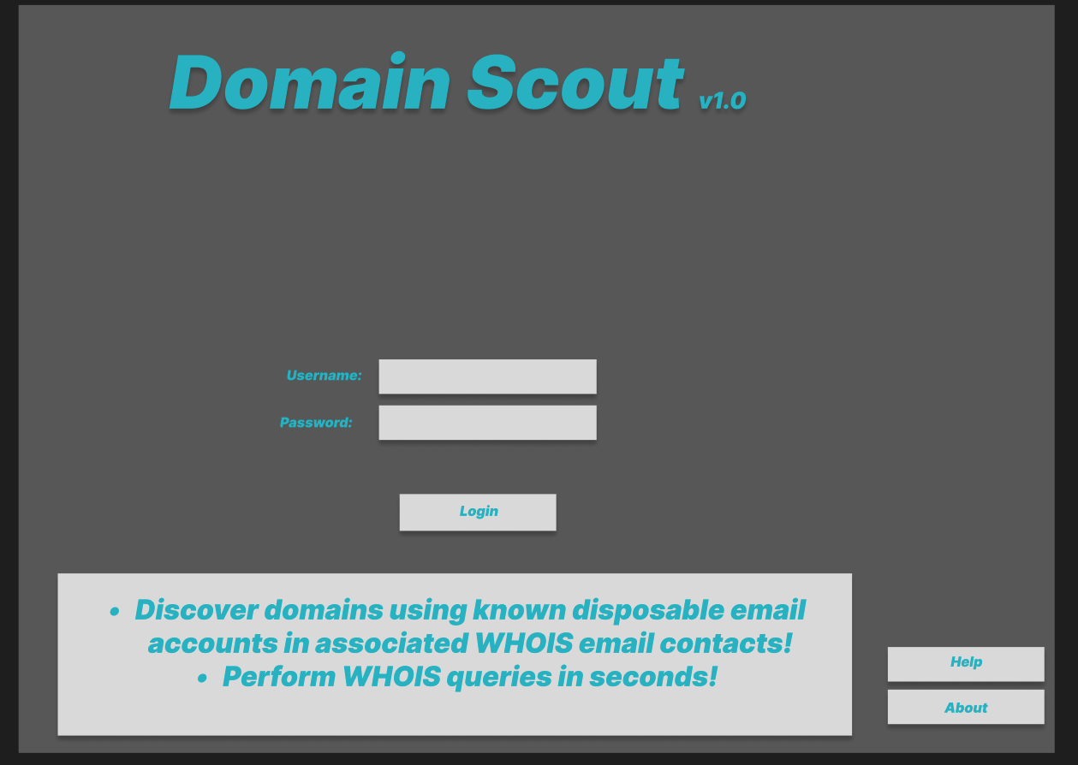
#R1

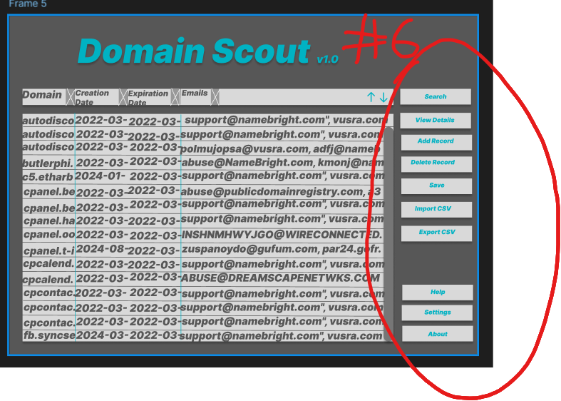
OLD

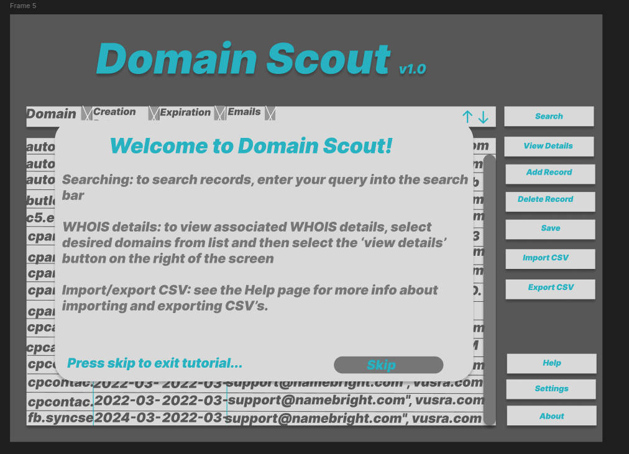
#R6

- How your design correctly reflects heuristic 1 (“Explain (to users) the benefits of using new and existing features”): To meet this heuristic, on the help page (#1), information is provided about the application’s features and how each works. This allows users to review the controls and functions of the application if they are unsure how to use it.
- REVISION: To meet this heuristic, on the welcome screen, (#R1) users are provided with info about the main features of this app. (To discover and view domains using known disposable emails in WHOIS contact info and to view corresponding WHOIS info for those domains). This allows users to gain an idea of the benefits of using the app before actually using it.

- How your design correctly reflects heuristic 6 (“Provide an explicit path through the task”): To meet this heuristic, buttons are clearly labeled with their actions and the buttons ‘indent’ when pressed allowing users to know for sure they pressed a button (#6).

REVISION: To meet his heuristic, on the main page after logging in (#R6), users are presented with a pop up with the different operations they can select and information about where to go for help (e.g. the help page). Users are also provided with a method to skip the tutorial.

